# PLSQL –DBMS

BEGIN

DBMS_OUTPUT.PUT_LINE('PL/SQL IS EASY!');

END;

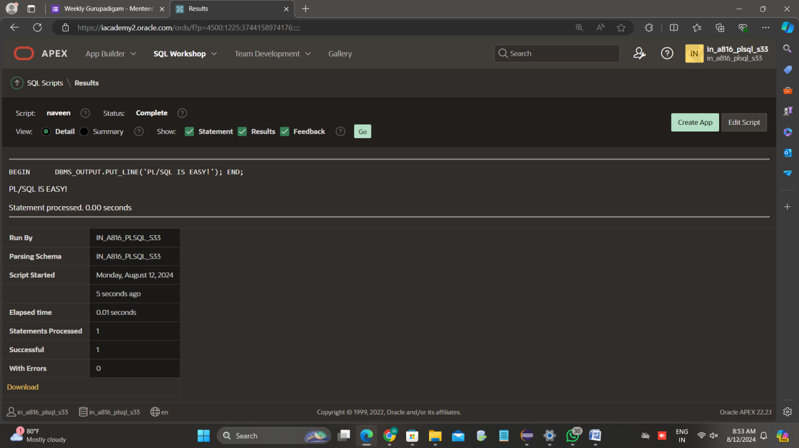

DECLARE

V_DATE DATE := SYSDATE;

BEGIN

DBMS_OUTPUT.PUT_LINE(V_DATE);

END;

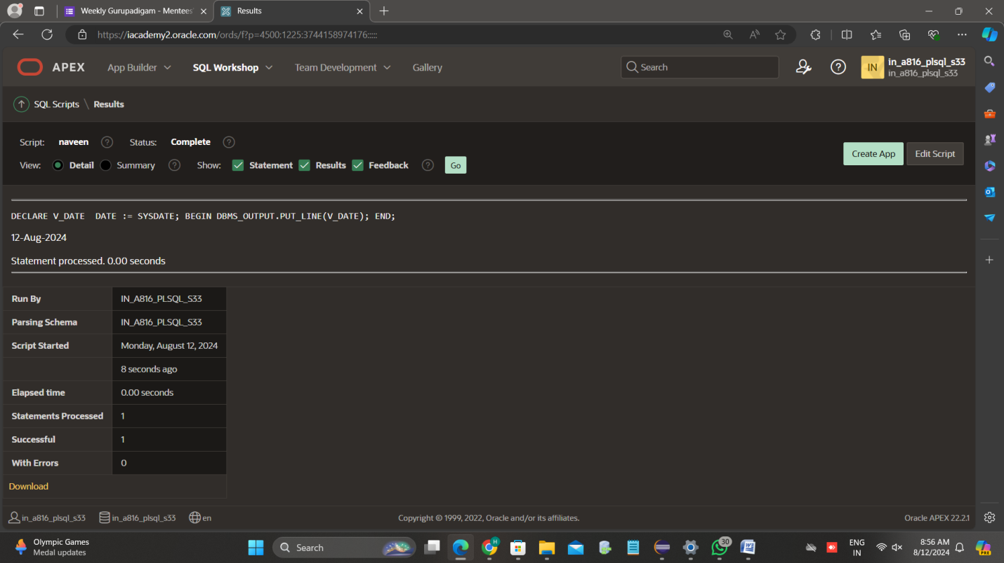

DECLARE

v_FIRST_NAME VARCHAR2(25);

v_LAST_NAME VARCHAR2(25);

BEGIN

SELECT FIRST_NAME,LAST_NAME

INTO v_FIRST_NAME, v_LAST_NAME

FROM PERSON1

WHERE LAST_NAME = 'SR';

DBMS_OUTPUT.PUT_LINE ('The STUDENYT of the month is: '

|| v_FIRST_NAME || ' ' || v_LAST_NAME || '.');

EXCEPTION

WHEN TOO_MANY_ROWS THEN

DBMS_OUTPUT.PUT_LINE ('Your select statement retrieved

multiple rows. Consider using a cursor or changing

the search criteria.');

END;

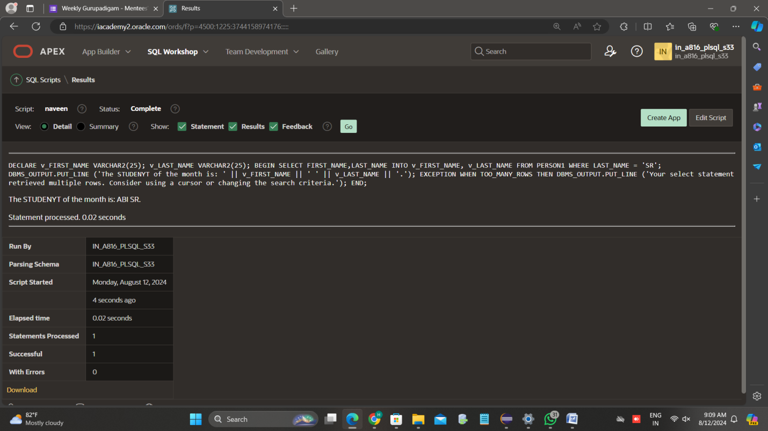

# SUBPROGRAM CODE BLOCKS

CREATE OR REPLACE PROCEDURE print_date IS

v_date VARCHAR2(30);

BEGIN

SELECT TO_CHAR(SYSDATE,'Mon DD, YYYY')

INTO v_date

FROM DUAL;

DBMS_OUTPUT.PUT_LINE(v_date);

END;

# ADDING TWO NUMBERS

DECLARE

a1 integer := 10;

b1 integer := 20;

c1 integer;

f1 real;

BEGIN

c1 := a1 + b1;

dbms_output.put_line('Value of c: ' || c1);

f1 := 70.0/3.0;

dbms_output.put_line('Value of f: ' || f1);

END;

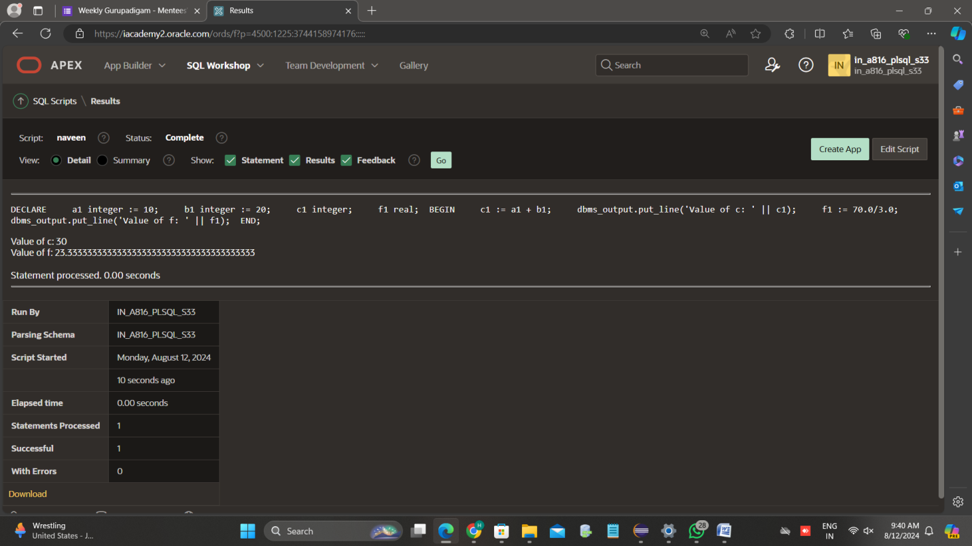

# CIRCLE

DECLARE

-- constant declaration

pi constant number := 3.141592654;

-- other declarations

radius number(5,2);

dia number(5,2);

circumference number(7, 2);

area number (10, 2);

BEGIN

-- processing

radius := 9.5;

dia := radius * 2;

circumference := 2.0 * pi * radius;

area := pi * radius * radius;

-- output

dbms_output.put_line('Radius: ' || radius);

dbms_output.put_line('Diameter: ' || dia);

dbms_output.put_line('Circumference: ' || circumference);

dbms_output.put_line('Area: ' || area);

END;

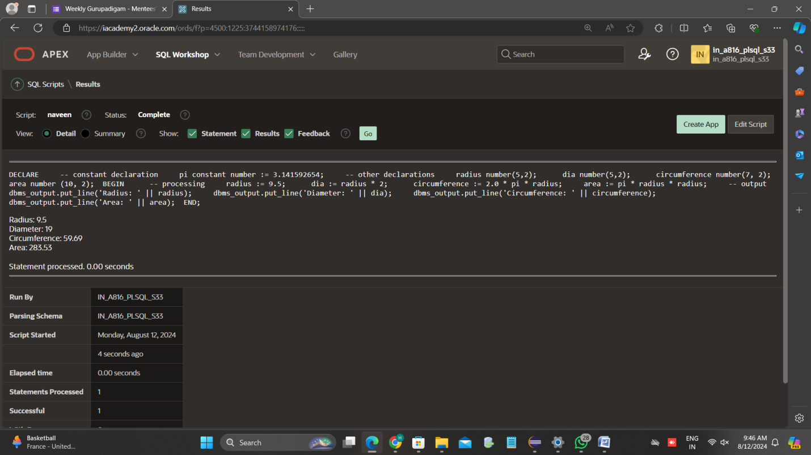

# GREATER

DECLARE

A1 INTEGER:=7;

B1 INTEGER:=4;

BEGIN

IF A1>B1 THEN

dbms_output.put_line('GREATER IS A1');

ELSIF A1<B1 THEN

dbms_output.put_line('GREATER IS B1');

END IF;

END;

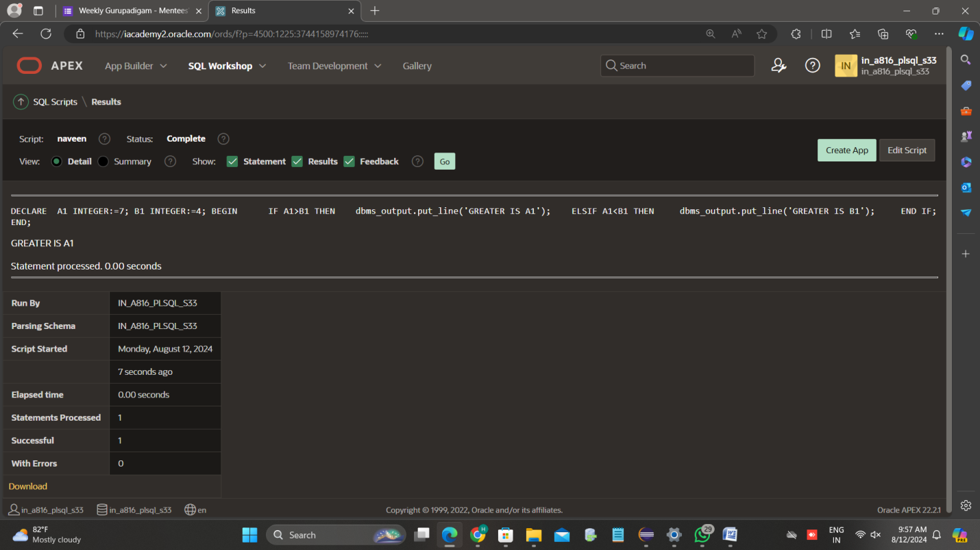

# TO COUNT THE NO.OF.CHARACTERS AND WORDS

DECLARE

str VARCHAR2(40) := 'Tutorials Point';

nchars NUMBER(4) := 0;

nwords NUMBER(4) := 1;

s CHAR;

BEGIN

FOR i IN 1..Length(str) LOOP

s := Substr(str, i, 1);

nchars:= nchars+ 1;

IF s = ' ' THEN

nwords := nwords + 1;

END IF;

END LOOP;

dbms_output.Put_line('count of characters is:'

||nchars);

dbms_output.Put_line('Count of words are: '

||nwords);

END;

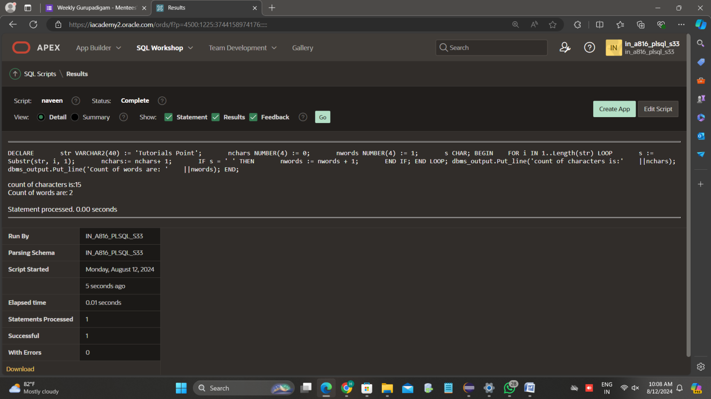

# SUM OF N NUMBERS

DECLARE

x NUMBER;

n NUMBER;

i NUMBER;

FUNCTION Findmax(n IN NUMBER)

RETURN NUMBER

IS

sums NUMBER := 0;

BEGIN

FOR i IN 1..n

LOOP

sums := sums + i*(i+1)/2;

END LOOP;

RETURN sums;

END;

BEGIN

n := 4;

x := findmax(n);

dbms_output.Put_line('Sum: '

|| x);

END;

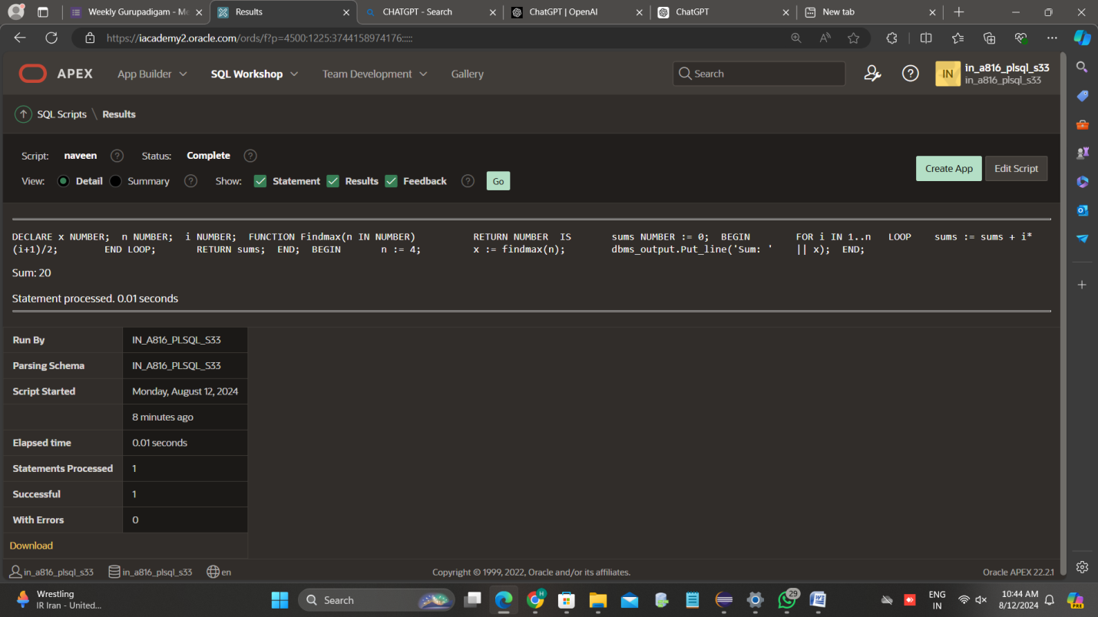

# EVEN NUMBERS

DECLARE

start_num NUMBER := 1;

end_num NUMBER :=10 ;

BEGIN

FOR i IN start_num..end_num LOOP

IF MOD(i, 2) = 0 THEN

dbms_output.Put_line(i);

END IF;

END LOOP;

END;

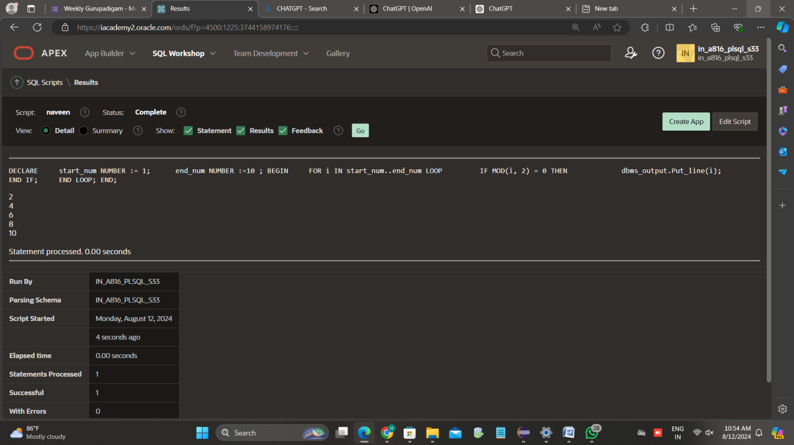

# 14.08.2024 (Wednesday)

# MAXIMUM

DECLARE

a number;

b number;

c number;

FUNCTION findMax(x IN number, y IN number)

RETURN number

IS

z number;

BEGIN

IF x > y THEN

z:= x;

ELSE

Z:= y;

END IF;

RETURN z;

END;

BEGIN

a:= 23;

b:= 45;

c := findMax(a, b);

dbms_output.put_line(' Maximum of (23,45): ' || c);

END;

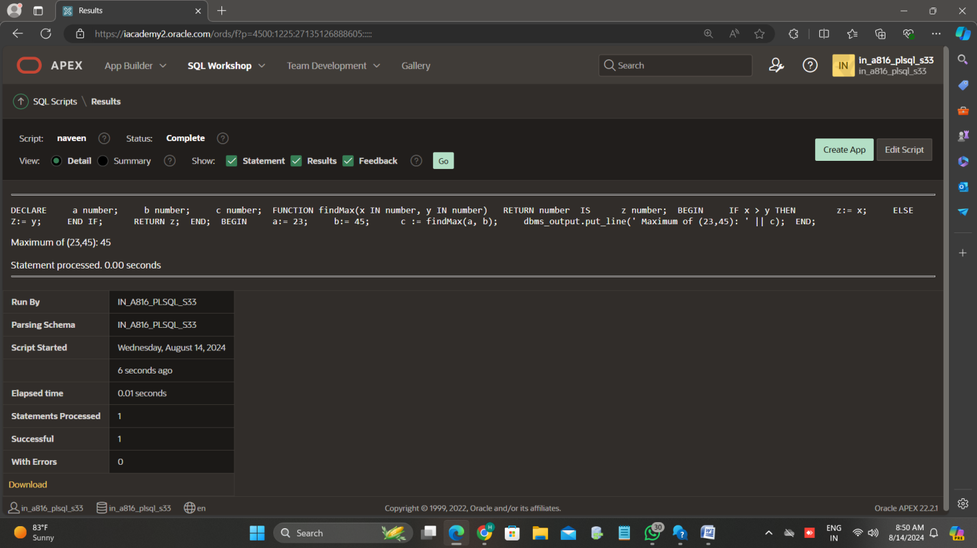

# FACTORIAL(FUNCTION)

DECLARE

num number;

factorial number;

FUNCTION fact(x number)

RETURN number

IS

f number;

BEGIN

IF x=0 THEN

f := 1;

ELSE

f := x * fact(x-1);

END IF;

RETURN f;

END;

BEGIN

num:= 6;

factorial := fact(num);

dbms_output.put_line(' Factorial '|| num || ' is ' || factorial);

END;

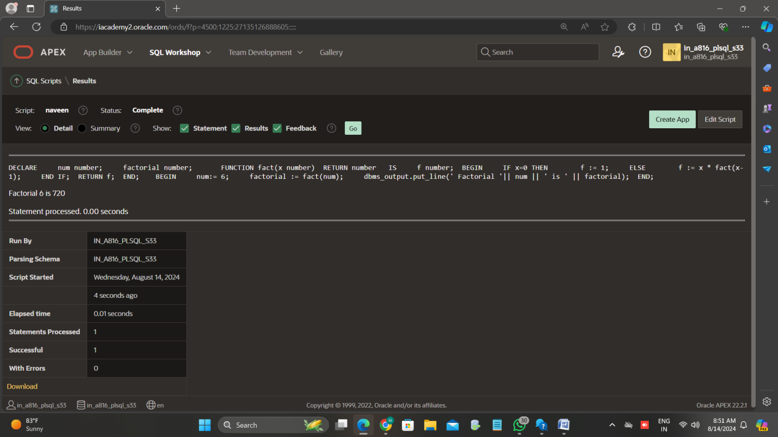

# FIBONACCI SERIES

CREATE OR REPLACE FUNCTION fibonacci(n IN NUMBER) RETURN NUMBER IS

result NUMBER;

BEGIN

IF n <= 0 THEN

result := 0;

ELSIF n = 1 THEN

result := 1;

ELSE

result := fibonacci(n - 1) + fibonacci(n - 2);

END IF;

RETURN result;

END;

/

DECLARE

num_terms NUMBER := 5;

i NUMBER;

fib_num NUMBER;

BEGIN

FOR i IN 1..num_terms LOOP

fib_num := fibonacci(i);

DBMS_OUTPUT.PUT_LINE('Fibonacci term ' || i || ' : ' || fib_num);

END LOOP;

END;

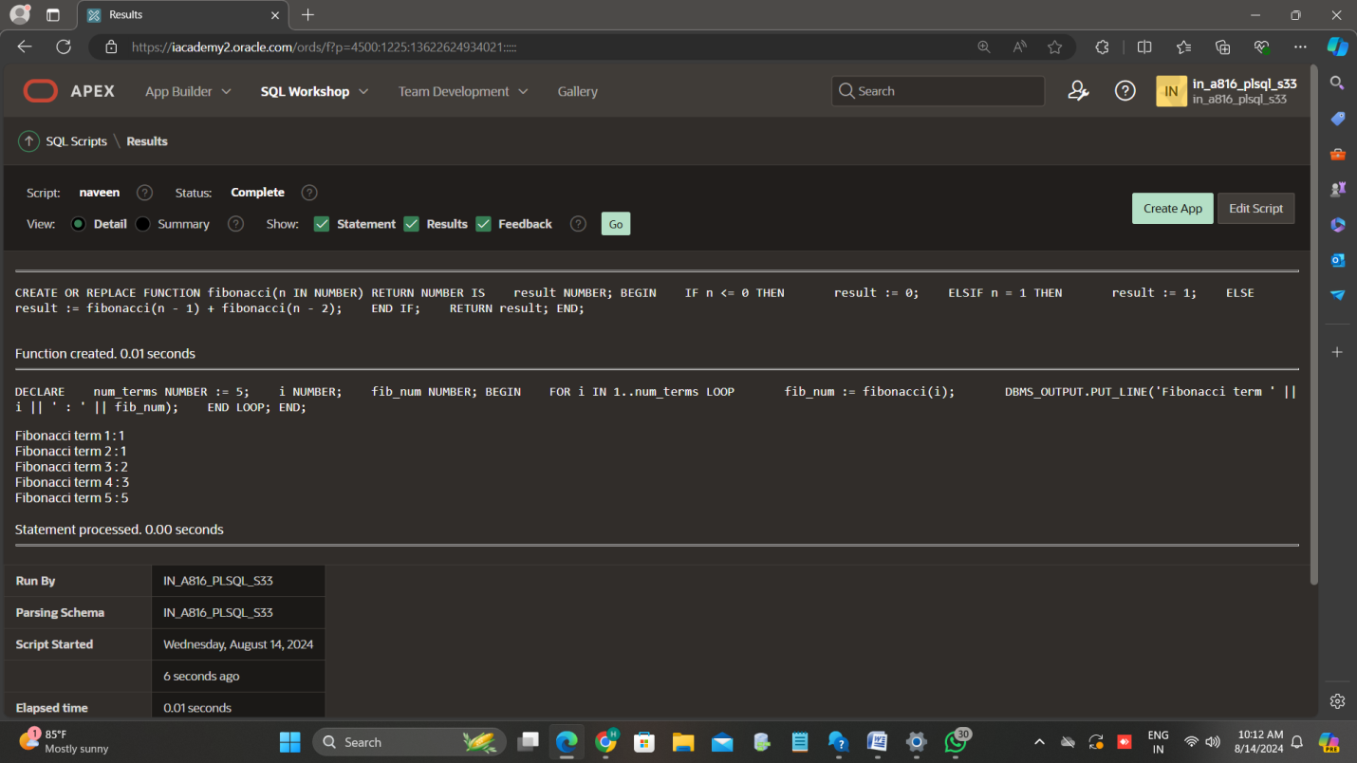

# 13.08.2024(TUESDAY)

# 1.

DECLARE

type namesarray IS VARRAY(5) OF VARCHAR2(10);

type grades IS VARRAY(5) OF INTEGER;

names namesarray;

marks grades;

total integer;

BEGIN

names := namesarray('Kavita', 'Pritam', 'Ayan', 'Rishav', 'Aziz');

marks:= grades(98, 97, 78, 87, 92);

total := names.count;

dbms_output.put_line('Total '|| total || ' Students');

FOR i in 1 .. total LOOP

dbms_output.put_line('Student: ' || names(i) || '

Marks: ' || marks(i));

END LOOP;

END;

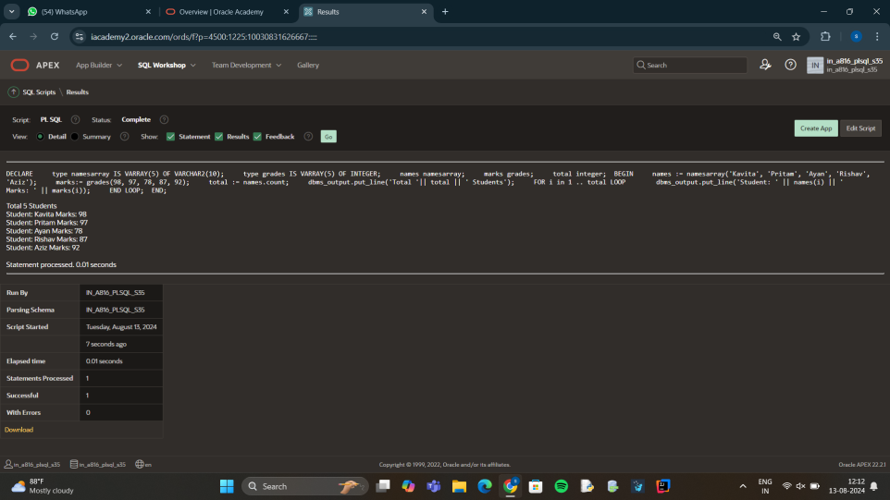

# 2.

DECLARE

type namesarray IS VARRAY(5) OF VARCHAR2(10);

type grades IS VARRAY(5) OF INTEGER;

type grade_labels IS VARRAY(5) OF VARCHAR2(2);

names namesarray;

marks grades;

total integer;

grade_label varchar(2);

BEGIN

names := namesarray('Kavita', 'Pritam', 'Ayan', 'Rishav', 'Aziz');

marks:= grades(98, 97, 78, 87, 92);

total := names.count;

dbms_output.put_line('Total '|| total || ' Students');

FOR i in 1 .. total LOOP

IF marks(i) >= 90 THEN

grade_label := 'A';

ELSIF marks(i) >= 80 THEN

grade_label := 'B';

ELSIF marks(i) >= 70 THEN

grade_label := 'C';

ELSIF marks(i) >= 60 THEN

grade_label := 'D';

ELSE

grade_label := 'F';

END IF;

dbms_output.put_line('Student: ' || names(i) || ' - Marks: ' || marks(i) ||' - Grade: ' || grade_label );

END LOOP;

END;

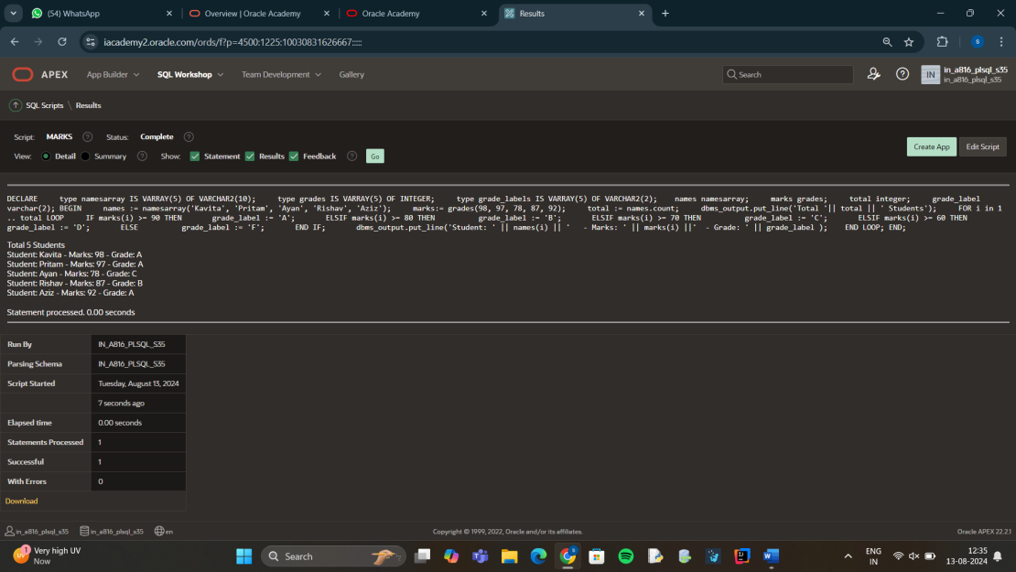

# 3.

DECLARE

NUMBER_TO_CHECK NUMBER := 23146579;

ODD_COUNT NUMBER := 0;

EVEN_COUNT NUMBER := 0;

CURRENT_DIGIT NUMBER;

BEGIN

WHILE NUMBER_TO_CHECK > 0 LOOP

CURRENT_DIGIT := MOD(NUMBER_TO_CHECK, 10);

IF MOD(CURRENT_DIGIT, 2) = 0 THEN

EVEN_COUNT := EVEN_COUNT + 1;

ELSE

ODD_COUNT := ODD_COUNT + 1;

END IF;

NUMBER_TO_CHECK := TRUNC(NUMBER_TO_CHECK / 10);

END LOOP;

DBMS_OUTPUT.PUT_LINE('Count of odd digits: ' || ODD_COUNT);

DBMS_OUTPUT.PUT_LINE('Count of even digits: ' || EVEN_COUNT);

END;

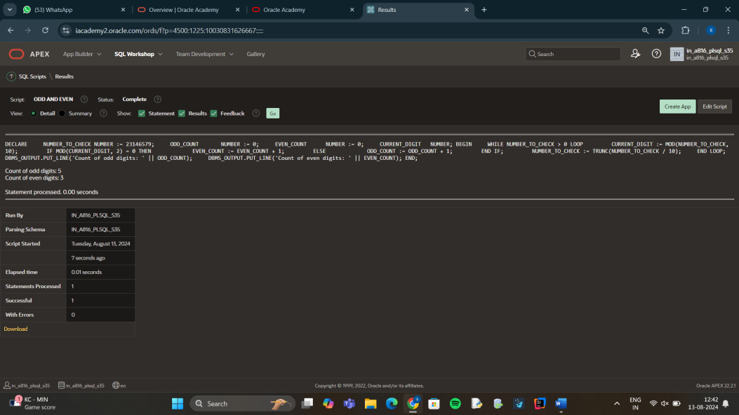

# 4.

DECLARE

v_emp_count NUMBER;

BEGIN

DBMS_OUTPUT.PUT_LINE('PL/SQL is easy so far!');

SELECT COUNT(*) INTO v_emp_count FROM student;

DBMS_OUTPUT.PUT_LINE('There are '||v_emp_count||'

rows in the employees table');

END;

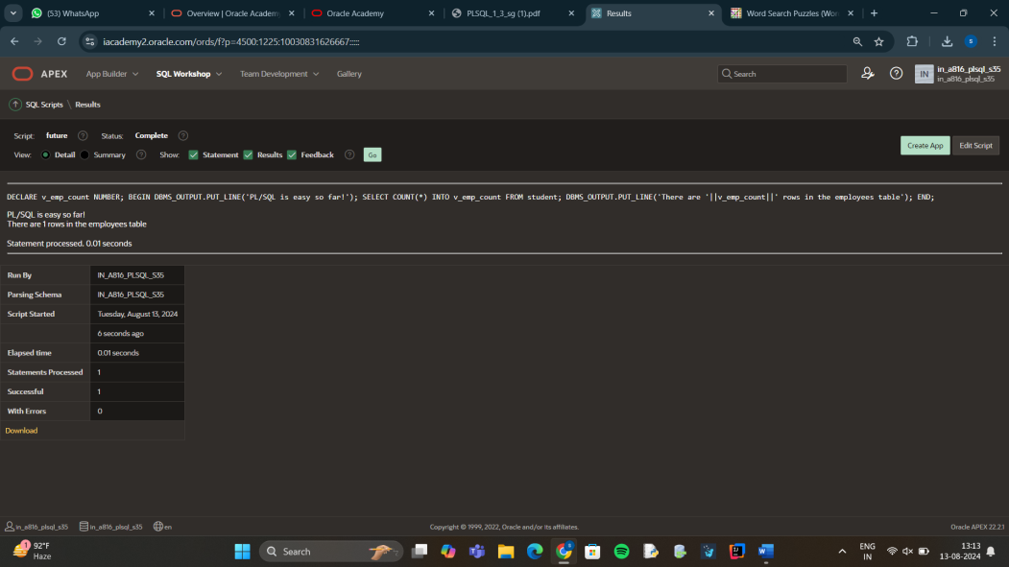

## 14.08.2024(WEDNESDAY)

DECLARE

total_rows number(2);

BEGIN

UPDATE PERSON1

SET MARKS = MARKS +50;

IF sql%notfound THEN

dbms_output.put_line('no customers selected');

ELSIF sql%found THEN

total_rows := sql%rowcount;

dbms_output.put_line( total_rows || ' customers selected ');

END IF;

END;

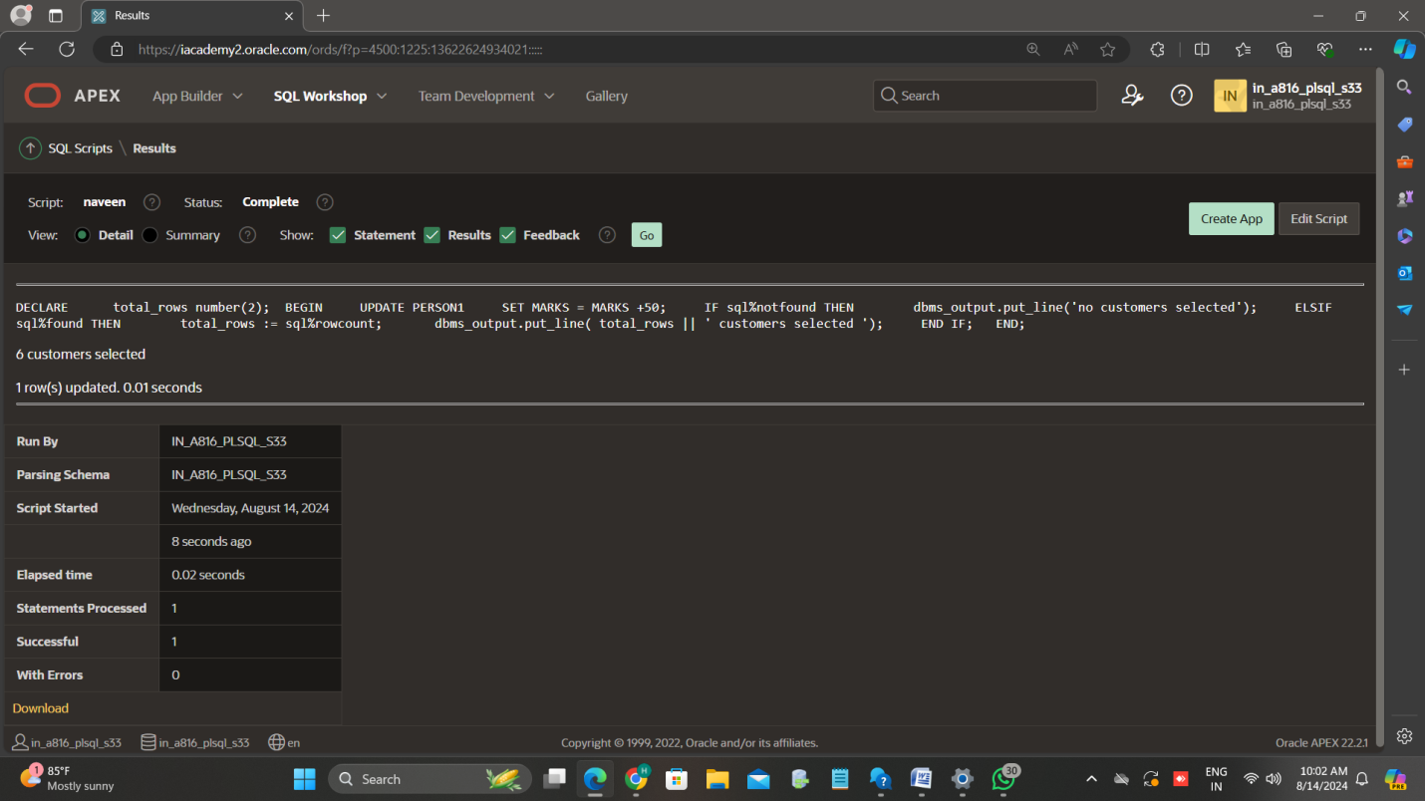

DECLARE

c_fname PERSON1.FIRSTNAME%type;

c_lname PERSON1.LAST_NAME%type;

c_marks PERSON1.MARKS%type;

CURSOR c_PERSON1 is

SELECT FIRST_NAME, LAST_NAME, MARKS FROM PERSON1;

BEGIN

OPEN c_PERSON1;

LOOP

FETCH c_PERSON1 into c_fname, c_lname, c_marks;

EXIT WHEN c_PERSON1%notfound;

dbms_output.put_line(c_fname || ' ' || c_lname || ' ' || c_marks);

END LOOP; 33

CLOSE c_PERSON1;

END; 